1. According to the order of operations, we must do the multiplication and division first, and then we can add and subtract.

2+15÷10−5+7×3= 2+1.5-5+21= 19.5 **(C)**.

2. The midpoint is the average of the x-values for the x-coordinate and the average of the y-values for the y-coordinate. Thus, the midpoint is ( ) = (11, 11), **(B)**.

3. Using elimination (getting rid of the x-value):

$-$ 6x + 21y = $-$ 39

        +   6x +   3y  =   21  
                     24y = $-$ 18

So, y= = **(B)**.

4. Adding the factors of 24 together, we get: 1+2+3+4+6+8+12+24 = 60 **(D)**.

5. Based on the first condition, Brandon is in last place.

__ __ __ __ __ B

If Nihar places behind Sri, and Sri is closer to last place, then first the line must be filled as:

__ __ __ S N B

Two places ahead of Sri is Josh, so:

__ J __ S N B

Since Townsend is not in third place, by process of elimination, Andrew must be third **(B)** The final lineup is: T J A S N B

6. Twenty-three out of the 100 students are watching neither snowboarding nor biathlon, so that means that 77 students are planning on watching at least one of these two events. Let the number of students who are going to watch both snowboarding and biathlon be *x*. If we add the number of people who are planning on watching snowboarding with the number of people who are planning on watching biathlon, we get 57+39=96. However, this 96 counts the people who are watching both biathlon and snowboarding twice (once in snowboarding and another time in biathlon), so we must subtract that amount to find the total number of people who will be watching at least one of these events. 96 $-$*x*=77, and solving for *x* we get *x*=19 **(B)**.

7. and 0.142857142… can be simplified to 17 and 1/7 respectively. Therefore, the only irrational numbers are $\sqrt{35}$ and π, two irrationals **(E)**.

8. The discriminant of a quadratic equation with the form y=ax2+bx+c is b24ac.

1824(3)(5)=32460=264 **(C)**.

9. Odds are given as “favorable outcomes : unfavorable outcomes”. Because the probability Andrew wins is ⅖, the number of times Andrew does not win (or the favorable outcome) is 3 (of 5), and the number of times this does not occur is 2 (of 5). Therefore, the odds he doesn’t win the Gold Medal are 3 : 2 **(D)**.

10. In order from smallest to largest, the scores are 8.9, 9.3, 9.4, 10.0. The median is the number in the middle; if there is an even number of scores, then it is the average of the middle two. Therefore, the median is (9.3 + 9.4)/2 = 9.35. The mean is the sum of all of the scores, divided by the number of scores: (8.9 + 9.3 + 9.4 + 10.0)/4 = 9.4. The sum of the mean and the median is 9.35+9.4=18.75, and when rounded to the nearest tenth, it is 18.8 **(D)**.

11. To determine the total number of outfits, simply multiply together the number of possibilities: , **(A)**

12. Starting within the parentheses, 34 32 = 34 9 = 25. 25 = 25 4 = 21 **(D)**.

13. First find the roots by factoring: (3x $-$ 7)(x + 4) = 0. Setting each factor to 0 yields x = $\frac{7}{3}$ or $-$ 4. We want the product, , **(A)**.

14. Ultimately, Andrew ends up 2.5 km north and 6 km east of his initial position. Applying the Pythagorean formula to this situation yields: $\sqrt{{2.5}^{2}+6^{2}}=\sqrt{42.25}=6.5$ km, **(B)**. You could also note that Andrew’s coordinates are half of the Pythagorean triple 5-12-13. Therefore, his distance from his starting point is

15. Reading carefully, the question asks for a line perpendicular to a perpendicular line. This is just a line parallel to the initial line, meaning they have a common slope of 3. 3*x $-$*y= $-$ 4 **(D)** is the only such line.

16. If Brandon cleans for one hour before Andrew starts helping, then Brandon will have cleaned $1/2$ of all the snowboards by the time Andrew starts, since Brandon can clean all the snowboards by himself in 2 hours. In one hour, Brandon will have washed $1/2$ of the boards, and Andrew will have washed $2/3$ of the boards, so together they will have washed $1/2$ + $2/3$ = $7/6$ of the boards in one hour. This means that, by working together, they will have washed all the boards in $6/7$ hours. However, since Brandon already cleaned $1/2$ of the boards by himself, the two boys only need to clean $1/2$ of the boards, which will take $1/2$ of the time. ($6/7)$ ($1/2)$ = $3/7$ of an hour. Adding this to the one hour that Brandon cleans alone, we get $7/7$ + $3/7$ = ${10}/7$ hours **(C)**.

17. The odd primes below 10 are 3, 5, and 7, so the number of shots Victoria makes is 3. The question asks for how many she misses, which is 103=7, **(E)**.

18. This problem describes an arithmetic sequence with first term 15 and a common difference of 0.75. To find the weight that Andrew lifts on the 30th day, or the 30th term in the sequence, we use the formula an=a1+(n1)d, where an=the nth term in the sequence, a1= the first term, n=the number of days, and d=the common difference. 15+(30 $-$ 1)(0.75)=15+21.75=36.75 **(C).**

19. Because Alex has a five minute head start, his goal is to finish the race in at most 25 minutes (five more than twenty—Andrew’s time). Plug in the values we know into the equation: rate = distance/ time. Alex’s rate = $\frac{10 km}{25 mimutes}$, but we want it in km/hr. So, , **(E)**.

20. Rationalizing the denominator, the numerator and denominator are both multiplied by 2+ $\sqrt{3}$, which is the conjugate of the denominator. FOILing and simplifying (7+ $\sqrt{3}$)(2+ $\sqrt{3}$) for the numerator and (2 $-\sqrt{3}$)(2+ $\sqrt{3}$) for the denominator, we get a numerator of (7+ $\sqrt{3}$)(2+ $\sqrt{3}$)=17+9 $\sqrt{3}$ and a denominator of (2 $-\sqrt{3}$)(2+ $\sqrt{3}$)=1. In the form a $-$ b $\sqrt{3}$, a=17 and b= $-$ 9. Therefore, ab=153 **(A)**.

21. If we add up the time Brandon takes in the morning before his first competition, we get: 17+25+32+50 = 124 minutes, or 2 hours and 4 minutes. Adding this to the 9 hours and 45 minutes of sleep he must get, we get 11 hours and 49 minutes. 11 hours and 49 minutes before 9:00 a.m. is 9:11 p.m **(D)**.

22. Using the point-slope formula for line A, with a point/y-intercept of (0,6) and a slope 5:

y $-$ 6 = 5(x $-$ 0) → y=5x+6

We can do the same thing for line B, but we first must find its slope.

(12.5 $-$ 0)/(3.5 $-$ 1) = 12.5/2.5 = 5

y $-$ 0 = 5(x $-$ 1) → y=5x $-$ 5

Line A and line B are parallel, since they have the same slope but different y-intercepts, so they never intersect/have any solutions. By definition, this means that these lines are inconsistent, or IV only **(B)**.

23. Noticing that each pair of adjacent numbers in 20 – 19 + 18 – 17…+ 4 – 3 + 2 – 1 (like 20 and 19, 18 and 17, and so on) has a difference of 1, we can count these in pairs. From the numbers 1 to 20, there are 20/2=10 groups of 2. Since each group has a value of 1, we multiply 10 by 1 to get 10 **(B)**.

24. Letthe number of Pokémon Andrew catches, $p=$ his placing, and $k=$ some constant. According to the definition of directly proportional, $p=k\sqrt{c}$. Next, we plug in the given numbers to solve for $k$, the constant. $6=k\sqrt{16}=4k$, so $k=\frac{3}{2}$. Plugging this $k$ back into the equation we found gives us $p=\frac{3}{2}c$, so we can now use this equation to solve for Andrew’s place with the new information. $p=\left(\frac{3}{2}\right)\left(\sqrt{4}\right)= \left(\frac{3}{2}\right)\left(2\right)=3$ or third place **(C)**.

25. Using the vertical line test determines if any of these are functions. If a vertical line hits more than one point, then it is *not* a function.

I. 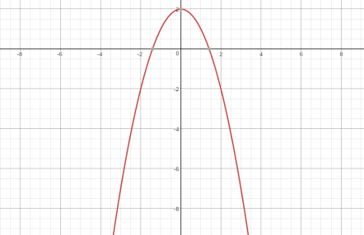II. 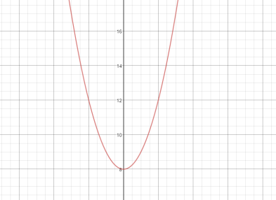III. 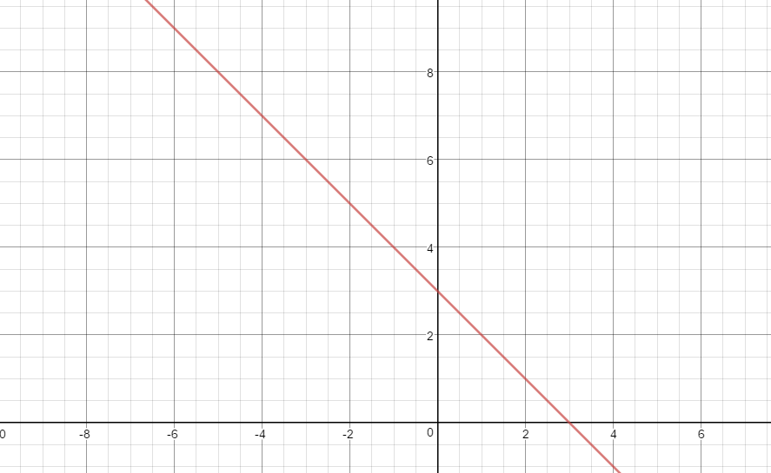IV. 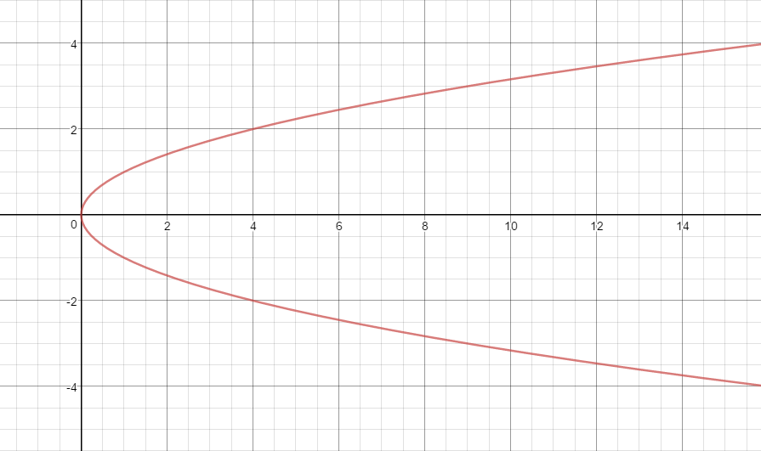

Therefore, IV is the only one that is not a function, 1 **(B)**.

26. First, find the number of days from 12/10/16 to 2/9/18. There are:

**365** (12/10/16-12/10/17)

**21** (12/10/17-1/1/18)

**31** (1/1/18-2/1/18)

**9** (2/1/18-2/9/18)

for a total of 426 days. Finding the remainder when divide by seven shows how many days “extra” we have that don’t fill up an entire week. The remainder is 6. This means, the day of the week six days after Saturday, is the day 2/9/2018 falls on, Friday **(B)**.

27. Remember, anything (except 0) to the 0th power is equal to 1. Therefore, if 3x25x28=0, then the left side of the equation will equal 1. Factoring this, we get (3x+7)(x $-$ 4)=0. This means that the quadratic equation has solutions of $-$ 7/3 and 4, so the sum of these two solutions is 5/3 **(A)**.

28. From her starting point to the pond, Jennifer goes a distance of $\sqrt{{(16-6)}^{2}+{(23-13)}^{2}}$ = $\sqrt{{10}^{2}+{10}^{2}}$ = $\sqrt{200}=10\sqrt{2}$. Therefore, her entire distance travelled is , **(C)**.

29. Setting the expression to equal zero, we solve for $X$: $X^{4}-256=0→ X^{4}=256$. The only real values that satisfy this are 4 and -4, two real roots, **(B)**.

30. For every Big Mac, Jennifer can get 17 chicken nuggets. Because she has 123 Big Macs, she can get a total of 123 $×$ 17 = 2091 chicken nuggets, **(B)**.